Adobe Stock

Definition
# Source: ScreenShots Source: Provided by: [Persons Table -> ID Column: 1, Name_En Column: Motasem Essam] -> Tool: [Lightshot Program] -> From [Site: https://www.alamy.com/] on [12/23/2025]
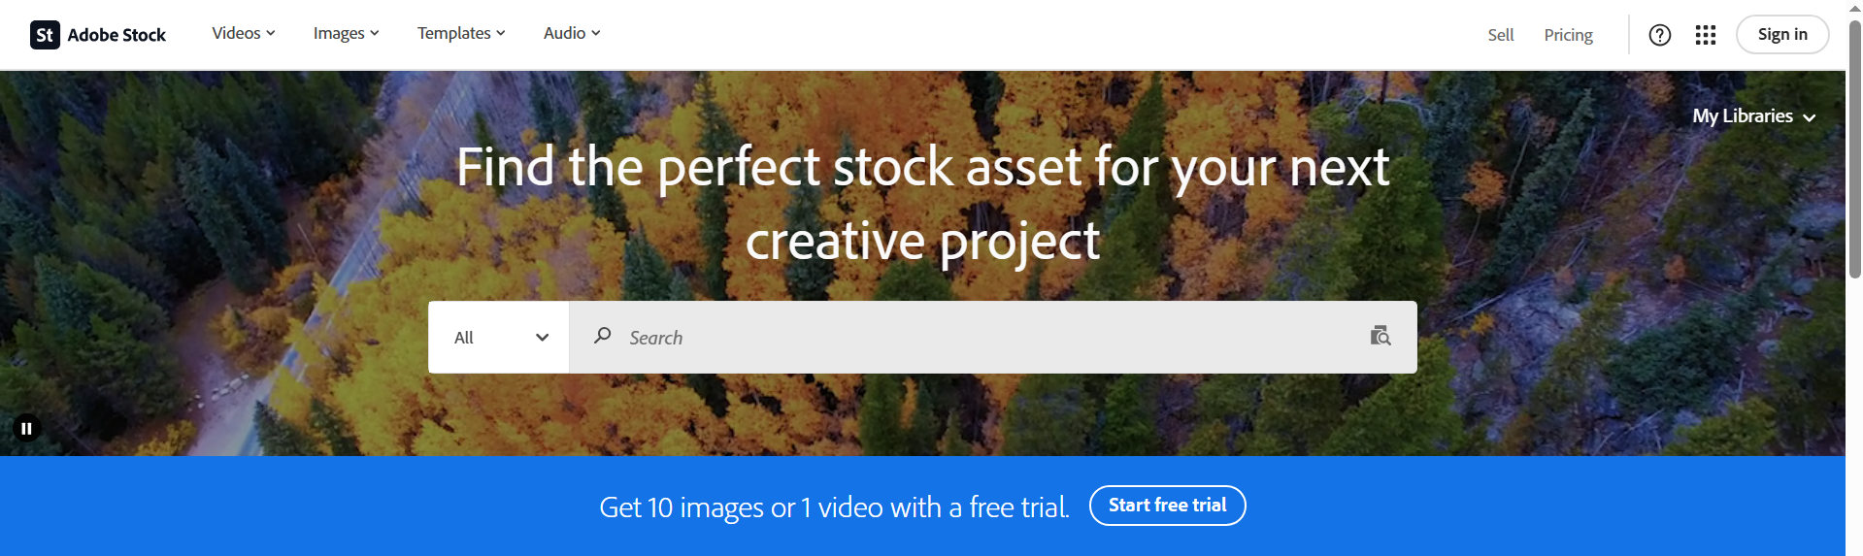
# Source: AI Source: Provided by: [Data Path: Persons Table -> ID Column: 1, Name_En Column: Motasem Essam] -> From: [ChatGPT] on [12/23/2025]
Adobe Stock is an online stock media website and service owned by Adobe.

What Adobe Stock provides
# Source: AI Source: Provided by: [Data Path: Persons Table -> ID Column: 1, Name_En Column: Motasem Essam] -> From: [ChatGPT] on [12/23/2025]
- Stock photos (images)
- Illustrations & vectors
- Videos
- Templates & 3D assets
- Audio (music & sound effects)

What it’s used for
# Source: AI Source: Provided by: [Data Path: Persons Table -> ID Column: 1, Name_En Column: Motasem Essam] -> From: [ChatGPT] on [12/23/2025]
People use Adobe Stock to get ready-made creative assets for:
- Websites
- Apps
- Social media posts
- Presentations
- Marketing and design projects

Key points
# Source: AI Source: Provided by: [Data Path: Persons Table -> ID Column: 1, Name_En Column: Motasem Essam] -> From: [ChatGPT] on [12/23/2025]
- It is a commercial stock platform (mostly paid content)
- Assets come with licenses that define how they can be used
- It integrates directly with Adobe apps like Photoshop, Illustrator, and Premiere Pro
- Files are often delivered through ftcdn.net, Adobe’s content delivery network (CDN)

